# Homework 2 Packet switching and routers

1. Data is sent across a network using a method called packet switching.  
   1. Explain what is meant by the term ‘packet switching’. [3]

A method of data transmission where data or files that are sent are broken down into smaller pieces of data of fixed size called packets. These packets are sent through the network via the same routes or different routes, since some parts of network might have more traffic, once the packets arrive to the destination, once they are all there, they are reassembled and put together to form the original data or file.

* 1. Explain why the sender’s address is included in the packet header. [2]

So the recipient knows who sent the data, without it the recipient wouldn’t know where to send a reply, if they needed to reply. For example you send an email to someone, but your address isn’t in the packet header, if it is a question or inquiry email then the recipient wouldn’t know how to reply to you because they don’t have your address so they cant reply to you.

1. Packets are forwarded from one node to another in a network. These may be routers   
   or gateways. Briefly describe the difference between a router and a gateway. [1]

Routers are networking devices that forwards data packets between different networks based on their IP address, it decides the best path of travel for data, whereas gateway, is a networking device that connects two different networks using different protocols. It acts as a bridge for communication between different systems.

# A file is being transferred between two computers across a network.

1. Identify a protocol that could be used to transfer this file [1]

File transfer protocol FTP

1. The network uses TCP/IP as shown below

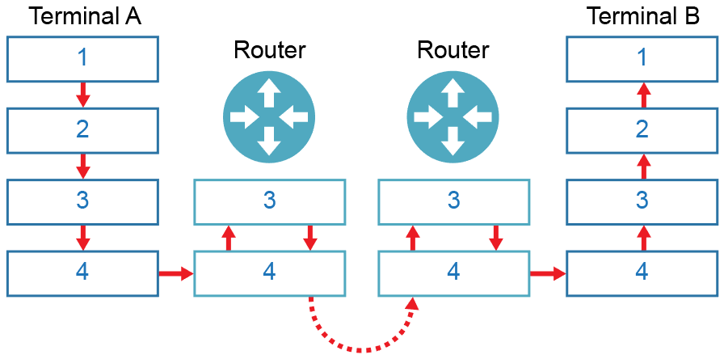

The numbers represent the layers of the TCP/IP stack. Name the layers   
in the table below: [4]

|  |  |
| --- | --- |
| **Label** | **Layer** |
| 1 | Application |
| 2 | Transport |
| 3 | Network / Internet |
| 4 | Link |

1. Data packets travel from router to router on layers 3 and 4. As this happens, their headers change. Explain why this is the case with reference to IP and MAC addresses. [5]  
   when the data is first broken down into packets, each packet consists of payload and header, payload is the data itself and header consists of data on the packet, like sender’s address, address it is going to, it’s sequence number, but it also includes the IP and MAC addresses of where it is coming from and going to. The MAC address shows where the next destination of the packet is, since packets travel across networks via routers, so in this case, the MAC address shows which the next router the packet goes to. Once the packet goes to the next router, it reaches layer 4 and goes up to 3 where it is stripped of the current MAC address, which is the address of where the current router the packet is on is. Then a new MAC address is added, which shows where the next router the data packet has to go to. This repeats everytime the packet arrives at a new router across the network. Since the MAC address is constantly being stripped and a new one added, the headers change since the MAC address is part of the header. This happens until the last router where the router’s MAC is stripped, and the intended device the data is for, that device’s MAC address is added on so the data packet can get to the specific device. Everytime it arrives at a new network, the source MAC is changed too since the packet is coming from the router it is on, to the next router and so on. The IP of original sender’s address stay the same since it is used to extract the data or reassemble the packets. At each destination, the packet also goes down to layer 4 before it is retransmitted, the TCP sequence numbers may be updated if packets are lost, since the routers will trigger retransmission

# A self-employed Accountant runs his own business from a small office. He has an email server that is used to communicate with his clients.

1. Identify **one** protocol and its associated port that he can use to read email   
   held on this server. [2]

Post office protocol POP3; 110:

1. The email account also uses his Smartphone to access emails. He finds that   
   emails he reads in the office do not appear on his phone. Explain why this is. [2]

POP3 downlodads emails from server and then removes them. IMAP keeps emails on the server but since he might be using POP3, the IMAP has not been used so it has been deleted from the server already.

[Total 20 Marks]